**Week 1 Module 1.3 Assignment**

Juan Macias Vasquez

Bellevue University

CSD325-H323 Advanced Python (2255-DD)

**Jack Lusby**

June 1st, 2025

Module 1.3 Assignment: beer on the Wall

Results Document

**Flow Chart**

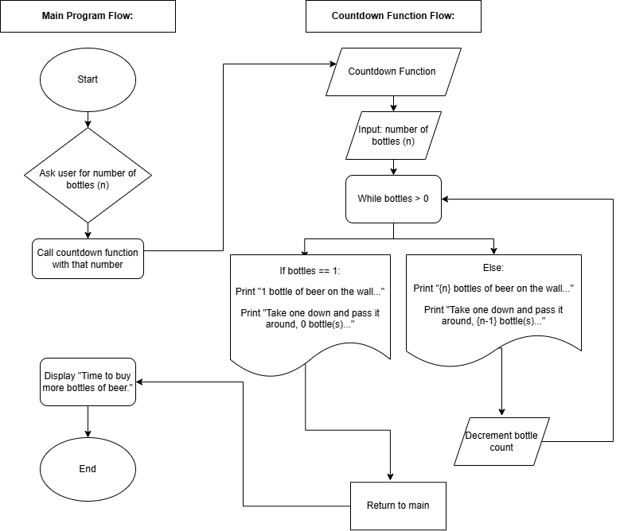

Made in draw.io

**Python Code**

# Juan Macias Vasquez

# Date 05/15/2025

# Module 1.3 Bottles of Beer

#Program

def beer_song(count):

while count > 0:

if count == 1:

print(f"{count} bottle of beer on the wall, {count} bottle of beer.")

print(f"Take one down and pass it around, 0 bottle(s) of beer on the wall.\n")

else:

print(f"{count} bottles of beer on the wall, {count} bottles of beer.")

print(f"Take one down and pass it around, {count - 1} bottle(s) of beer on the wall.\n")

count -= 1

# Main program

def main():

try:

bottles = int(input("Enter number of bottles: ")) #Get number of beers from user

if bottles <= 0:

print("Please enter a positive number.")# Make sure its positive

else:

beer_song(bottles)

print("Time to buy more bottles of beer.")

except ValueError:

print("Please enter a valid integer.")# If not a number

# Run the program

main()

**Picture of code running**

